Create Security Group

Go to the SailPoint IIQ application here: https://iga.int.thomsonreuters.com

Select Group Management > Request Security Group under “hamburger menu”
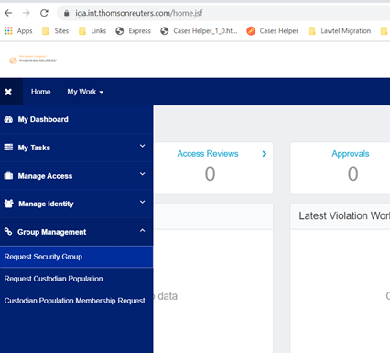
Select the Business Application Name in Asset Insight (this is the name of your application as is registered in the Asset Insight system - https://assets.int.thomsonreuters.com/)
- Note: The Application Contact (auto populated from Asset Insight data) will be the approver for this new security group request

Group Display Name
The Group Display Name is just a display name and not used for technical purposes, so it can be descriptive if desired to make it easier to find in the list of groups later.
Group Technical Name
- Group Technical Name is automatically prefixed with “APP-{yourAppName}-{yourAppAIID}-” (e.g., “APP-myApp-A123456-...").
- The text after this prefix must be named: “MCB-BOT” (MCB is standing for MFA/CAPTCHA Bypass):

Requestable?: Yes
- Note: This should be reverted to “No” later when the bot account is added to it to disallow future requests for membership in the group
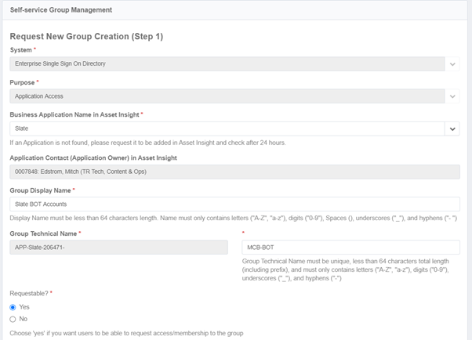
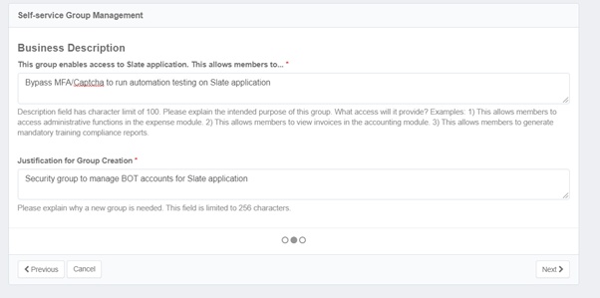

Group Custodian
Select “New Group Custodian Population” if you don’t have existing one. A group custodian group will hold the approvers for the MFA/CAPTCHA group being created.
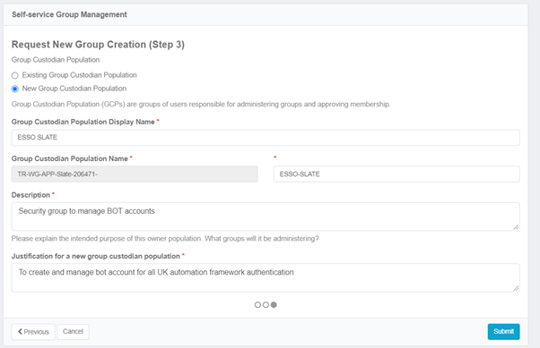

You can check the status of your request under Track My Request from home page Dashboard options
Once the app owner approves, the status becomes Success
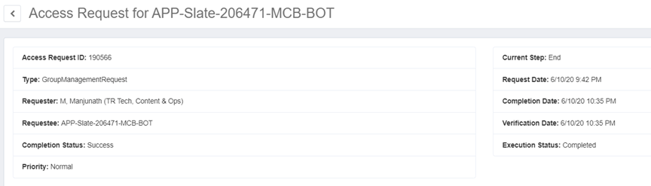

Create BOT account
This process is detailed in another document maintained by the IAM Governance Team at https://identity.int.thomsonreuters.com/documents/creating-bot-identities-fieldglass.pdf
with general details around BOTs at IAM Info Portal (thomsonreuters.com)
NOTE: It is crucial that you complete MFA registration on the BOT account, even though you will be bypassing MFA on your app for your planned usage. Failure to do so in a timely manner will result in your BOT being disabled!

Add the bot account to the security group

- Go to the SailPoint application (https://iga.int.thomsonreuters.com)
- Login with bot account details
- Go to Manage Access > Manage My Access
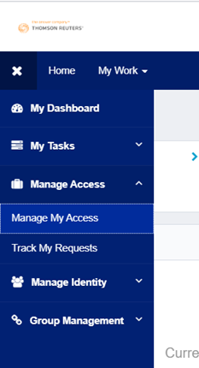
- Search security group by providing part of the “Group Technical name” which you have provided while creating Security Group (the MCB-BOT one, not the WG custodian one)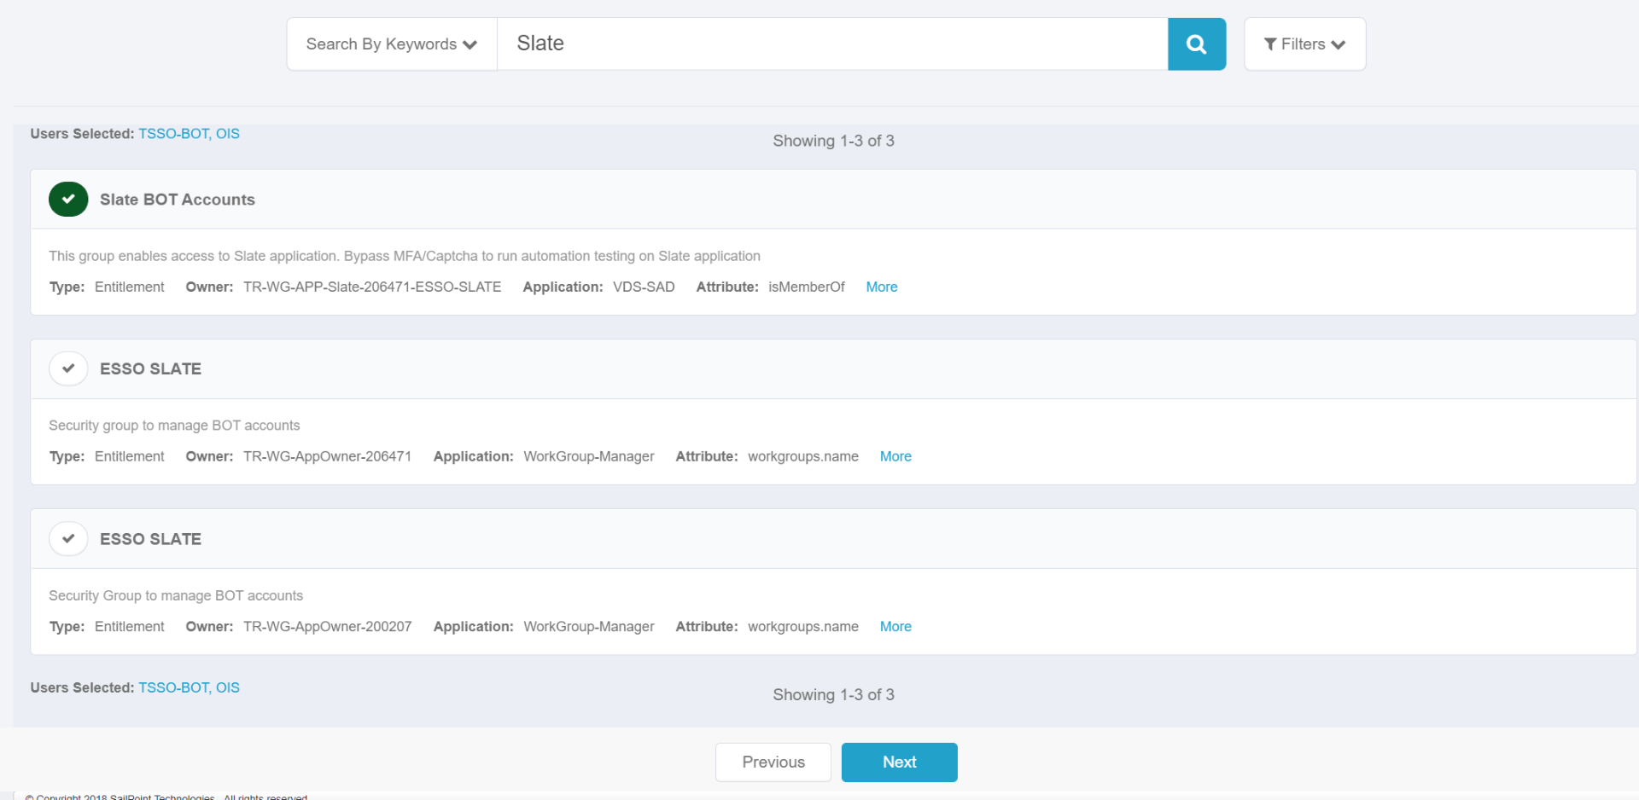
- Click on the tick mark to add the group the selected account and press Next
- See the notification at the top of the screen: "Request submitted successfully. The ID for this request is ######."
- Approve the access request when the notification arrives
Note: If you are not one of the group's custodians (approvers), you can monitor your access request via SailPoint | hamburger menu | Manage Access | Track My Requests
Check status under My Work > Access Request
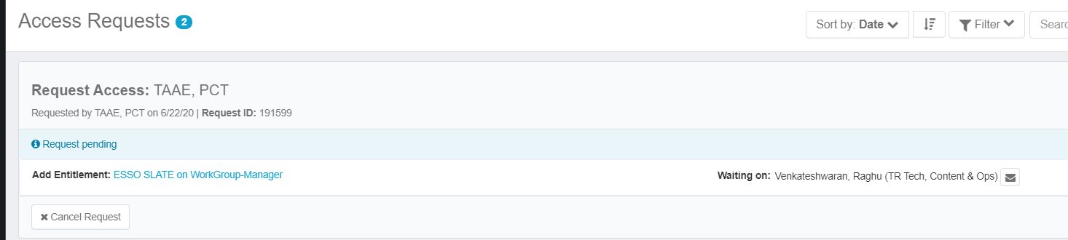

Request update on your eSSO integration for bypass
Open a ticket to update your integration and indicate that you wish to enable MFA/Captcha bypass (also called a BOT bypass). Be sure to share the Security Group name (the MCB-BOT one) and your application ESSO client ID details. These requests are manually processed, and should either be completed or followed-up on with any questions within three business days.

Using the MFA/CAPTCHA Bypass Authentication Flow

An HTTP request parameter “bypassmfacaptcha” with value “true” must be included on the initial SSO request. If this parameter is not present on the request, the regular login flow will be enforced.
Esso url sample with bypassmfacaptcha=true parameter
https://sso.thomsonreuters.com/as/authorization.oauth2?client_id=chipsdevtest&scope=openid%20email%20profile&response_type=code&redirect_uri=https%3A%2F%2Fchips-test.int.thomsonreuters.com%3A8128%2FoidcRedirect&state=omHu18_smRB-aSPrLVxWEg6sgaialOeJSdSCeC4br1M&client_secret=UpoAE1Nz0FykqIN2HwapelexHiuHpkpPTONWdhb1YcEiITglA2tYS0Fw3aIuTeRb&bypassmfacaptcha=true
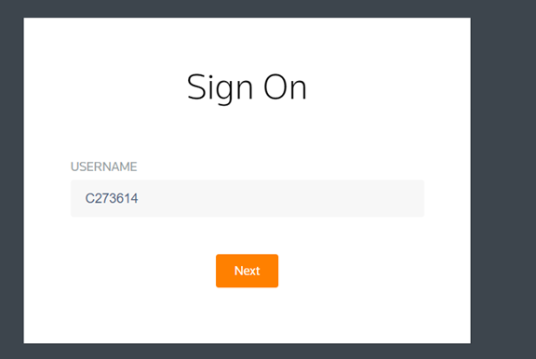
Login using bot account credentials and notice that ping id MFA has been skipped!!
If you get an error response after entering the username claiming 'access denied', it means the id provided didn't match a member of the group configured for bypass on your app. If this is a new integration shortly after getting approval that the bypass has been configured, let the Ops team know you encountered an issue. If this is an already-known working config for a different BOT, you may just need to add the new BOT to the existing bypass group.

